

Department of Computer Science

MY University, Islamabad.

**Implementation Phase (LAB)**

**Project No: 07**

**Course Title: Database System**

**Student Name: Taha Saddiqui**

**Registration No: baib232005**

**Batch: Fall2023**

**Program: Ai**

**Semester: 6th**

**Lab Instructor: Mr. Hamza Javed**

**Submission Date: 10/06/24**

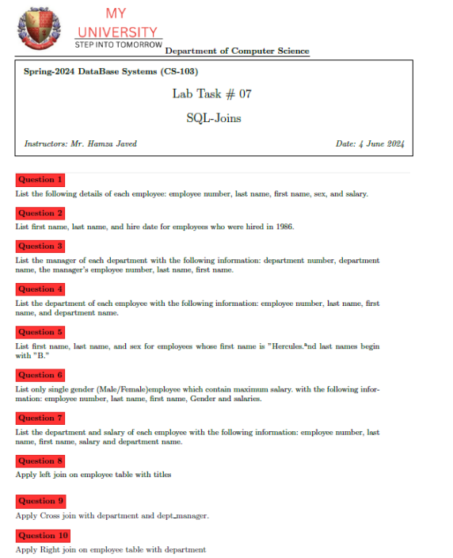

**Database And Table Queries**

USE dbproject7;

CREATE TABLE employees (

emp_no INT NOT NULL,

emp_title_id VARCHAR(5) NOT NULL,

birth_date DATE NOT NULL,

first_name VARCHAR(30) NOT NULL,

last_name VARCHAR(30) NOT NULL,

sex VARCHAR(1) NOT NULL,

hire_date DATE NOT NULL,

PRIMARY KEY (emp_no)

);

CREATE TABLE dept_manager (

dept_no VARCHAR(4) NOT NULL,

emp_no INT NOT NULL,

PRIMARY KEY (dept_no, emp_no),

FOREIGN KEY (emp_no) REFERENCES employees (emp_no) ON DELETE CASCADE,

FOREIGN KEY (dept_no) REFERENCES departments (dept_no) ON DELETE CASCADE

);

CREATE TABLE dept_emp (

emp_no INT NOT NULL,

dept_no VARCHAR(4) NOT NULL,

PRIMARY KEY (emp_no, dept_no),

FOREIGN KEY (emp_no) REFERENCES employees (emp_no) ON DELETE CASCADE,

FOREIGN KEY (dept_no) REFERENCES departments (dept_no) ON DELETE CASCADE

);

CREATE TABLE departments (

dept_no VARCHAR(4) NOT NULL,

dept_name VARCHAR(30) NOT NULL,

PRIMARY KEY (dept_no)

);

CREATE TABLE titles (

title_id VARCHAR(5) NOT NULL,

title VARCHAR(30) NOT NULL,

PRIMARY KEY (title_id)

);

CREATE TABLE salaries (

emp_no INT NOT NULL,

salary INT NOT NULL,

PRIMARY KEY (emp_no),

FOREIGN KEY (emp_no) REFERENCES employees (emp_no) ON DELETE CASCADE

);

**Instructions To load .csv Data into MySQL**

LOAD DATA INFILE 'D:\\Programs\\Datasets\\dept_manager.csv'

INTO TABLE dept_manager

FIELDS TERMINATED BY ','

ENCLOSED BY ' " '

LINES TERMINATED BY '\n'

IGNORE 1 ROWS;

LOAD DATA INFILE 'D:\\Programs\\Datasets\\dept_emp.csv'

INTO TABLE dept_emp

FIELDS TERMINATED BY ','

ENCLOSED BY ' " '

LINES TERMINATED BY '\n'

IGNORE 1 ROWS;

LOAD DATA INFILE 'D:\\Programs\\Datasets\\departments.csv'

INTO TABLE departments

FIELDS TERMINATED BY ','

ENCLOSED BY ' " '

LINES TERMINATED BY '\n'

IGNORE 1 ROWS;

LOAD DATA INFILE 'D:\\Programs\\Datasets\\titles.csv'

INTO TABLE titles

FIELDS TERMINATED BY ','

ENCLOSED BY ' " '

LINES TERMINATED BY '\n'

IGNORE 1 ROWS;

LOAD DATA INFILE 'D:\\Programs\\Datasets\\salaries.csv'

INTO TABLE salaries

FIELDS TERMINATED BY ','

ENCLOSED BY ' " '

LINES TERMINATED BY '\n'

IGNORE 1 ROWS;

LOAD DATA INFILE 'D:\\Programs\\Datasets\\employees.csv'

INTO TABLE employees

FIELDS TERMINATED BY ','

ENCLOSED BY ' " '

LINES TERMINATED BY '\n'

IGNORE 1 ROWS

**Question 1 : List the following details of each employee: employee number, last name, first name, sex, and salary.**

SELECT e.emp_no, e.last_name, e.first_name, e.sex, s.salary

FROM dbproject7.employees e

JOIN dbproject7.salaries s ON e.emp_no = s.emp_no

LIMIT 10;

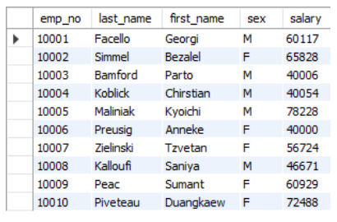

**Question 2 : List first name, last name, and hire date for employees who were hired in 1986.**

SELECT e.first_name, e.last_name, e.hire_date

FROM dbproject7.employees e

WHERE YEAR(e.hire_date) = 1986

LIMIT 10;

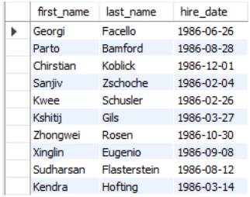

**Question 3 : List the manager of each department with the following information: department number, department name, the manager’s employee number, last name, first name.**

SELECT d.dept_no, d.dept_name, dm.emp_no, e.last_name, e.first_name

FROM dbproject7.departments d

JOIN dbproject7.dept_manager dm ON d.dept_no = dm.dept_no

JOIN dbproject7.employees e ON dm.emp_no = e.emp_no

LIMIT 10;

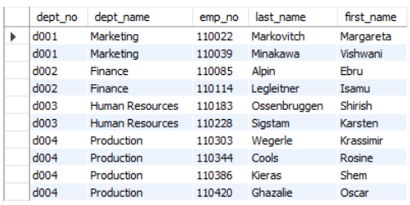

**Question 4 :** **List the department of each employee with the following information: employee number, last name, first name, and department name.**

SELECT e.emp_no, e.last_name, e.first_name, d.dept_name

FROM dbproject7.employees e

JOIN dbproject7.dept_emp de ON e.emp_no = de.emp_no

JOIN dbproject7.departments d ON de.dept_no = d.dept_no

LIMIT 10;

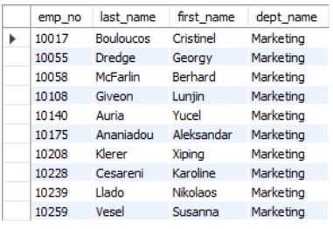

**Question 5 : List first name, last name, and sex for employees whose first name is ”Hercules” and last names begin with ”B.”**

SELECT e.first_name, e.last_name, e.sex

FROM dbproject7.employees e

WHERE e.first_name = 'Hercules' AND e.last_name LIKE 'B%'

LIMIT 10;

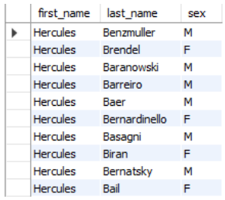

**Question 6 : List only single gender (Male/Female)employee which contain maximum salary. with the following information: employee number, last name, first name, Gender and salaries.**

SELECT e.emp_no, e.last_name, e.first_name, e.sex, s.salary

FROM dbproject7.employees e

JOIN dbproject7.salaries s ON e.emp_no = s.emp_no

WHERE (e.sex, s.salary) IN (

SELECT sex, MAX(salary)

FROM dbproject7.employees e

JOIN dbproject7.salaries s ON e.emp_no = s.emp_no

GROUP BY e.sex

)

LIMIT 10;

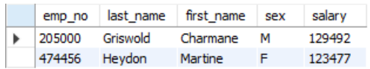

**Question 7 : List the department and salary of each employee with the following information: employee number, last name, first name, salary and department name.**

SELECT e.emp_no, e.last_name, e.first_name, s.salary, d.dept_name

FROM dbproject7.employees e

JOIN dbproject7.salaries s ON e.emp_no = s.emp_no

JOIN dbproject7.dept_emp de ON e.emp_no = de.emp_no

JOIN dbproject7.departments d ON de.dept_no = d.dept_no

WHERE e.emp_no IN (

SELECT MIN(de.emp_no)

FROM dbproject7.dept_emp de

GROUP BY de.dept_no

);

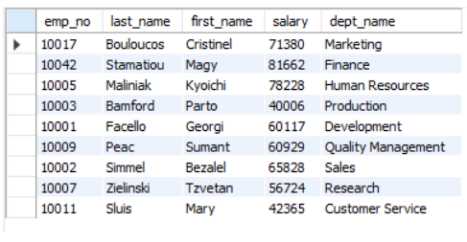

**Question 8 : Apply left join on employee table with titles.**

SELECT e.*, t.*

FROM dbproject7.employees e

LEFT JOIN dbproject7.titles t ON e.emp_title_id = t.title_id

LIMIT 10;

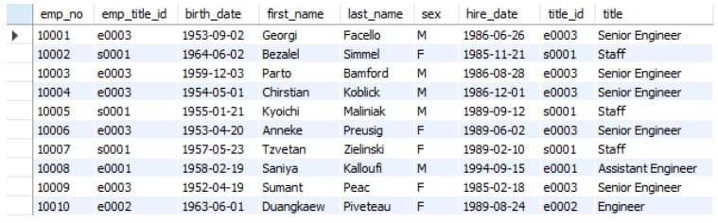

**Question 9 : Apply Cross join with department and dept manager.**

SELECT *

FROM dbproject7.departments d

CROSS JOIN dbproject7.dept_manager dm

LIMIT 10;

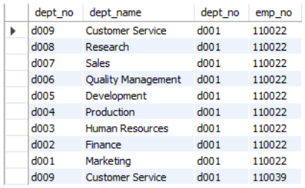

**Question 10 : Apply Right join on employee table with department.**

SELECT e.*, d.*

FROM dbproject7.employees e

RIGHT JOIN dbproject7.dept_emp de ON e.emp_no = de.emp_no

RIGHT JOIN dbproject7.departments d ON de.dept_no = d.dept_no

LIMIT 10;

